Earthworks Risk Management Plan

**Template** for mitigating the risk of PA spread through earthworks

**Table of Contents**

Version History 3

Background Information 4

PA National Pest Management Plan (PA NPMP) 4

Objective 5

Location Map 5

Proposed Operation 5

Operators Information 6

Site and Kauri Information 6

PA Management 6

Risk Matrix 7

PA Mitigations and Actions 7

Management Map8

Conclusion 9

Reporting and Compliance 9

Procedures for PA Management References 10

References 12

**Underlined sections are legally required to satisfy rule 5 of the PA NPMP. All other sections form part of best practice for managing PA. Although not legally required, inclusion of these sections is recommended as part of understanding and implementing Kauri protection measures.**

# Version History

|  |  |  |  |  |
| --- | --- | --- | --- | --- |
| **Plan Version** | | | |  |
| **Plan author:** | | | **Date created:** | |
| **Agency:** | | | | |
| **Version** | **Author** | **Date** | **Reason for updated** | **Sign Off** |
| **1.0** |  | As above | New plan for property |  |
|  |  |  |  |  |
|  |  |  |  |  |
|  |  |  |  |  |

Background Information

Kauri (Agathis australis) are a cornerstone of the indigenous forests of the upper North Island and have had a large part to play not just in the landscape of Aotearoa, but also in its culture and early history. To Māori, Kauri are kings of the forest and a taonga (treasure) that connects them and their spiritual world.

*Phytophthora agathidicida* (PA) is the pathogen that causes disease in Kauri. It was formally identified in 2009 and presumed to be exotic to NZ. PA is a soil-borne pathogen, with no airborne phase and no known cure. Minimising the movement of soil or plant material, potentially contaminated with PA, by people, their activities and animals is fundamental to the management of disease and the pathogen. Mitigations can be successful if appropriately implemented. Distribution of PA is sporadic, with sections of many forests known to be infected, but many others potentially pathogen free. As there is no known cure greater emphasis is placed on managing our activities in order to control spread of this deadly pathogen.

PA National Pest Management Plan (PA NPMP)

A National Pest management Plan (NPMP) for protecting Kauri from *Phytophthora agathidicida* (PA) came into effect on the 2nd August 2022. The plan contains objectives and principles which have been designed to protect Kauri from pathogen and the disease it causes. Included in the plan are 10 new rules. Rule number 5 is in relation to developing earthworks risk management plans around Kauri. This plan has been prepared to satisfy the legal requirements of rule 5 whilst using best practice for managing PA. It is important to note that approval of this plan under the NPMP does not alter any obligations under other legislation, including but not limited to district or unitary plan requirements or concession requirements for working on Public Conservation Land.

Rule application

In general, commencing earthworks within a Kauri Hygiene Zone without an approved earthworks PA risk management plan is an offence and can result in prosecution. Failure to operate in accordance with an approved plan is also an offence that can result in prosecution. There are a few scenarios where rule 5 does not apply, these are below. Instructions for submitting a plan are in the “Reporting and Compliance” section.

District and Unitary Earthworks Risk Management Plan exception

If your District or Unitary Plan requires you to complete an Earthworks PA Risk Management Plan, or similar, with the same core components as detailed the NPMP, there is no requirement to fill out a plan under rule 5, provided works are completed in compliance with the requirements of that District or Unitary plan.

Emergency works, pet burial and domestic gardening exceptions

An earthworks PA Pest management plan is not required if works are undertaken in response to an emergency – for the duration of that emergency. An emergency, for the purpose of this rule, is an adverse effect on the environment that requires immediate preventive or remedial measures; OR a sudden event causing or likely to cause loss of life, injury, or serious damage to property. A rule 5 plan is also not required for domestic gardening or the burial of animals, provided the occupier cleans all footwear, tools, and machinery used so that those items are free of visible soil and organic material prior to entry into and exit from the kauri hygiene zone.

# Objective

State the objective of the plan. Include the relevant text of rule 5 objective which can be found in the **How to Guide.**

|  |  |
| --- | --- |
| **Plan objective** |  |

Location Map

Insert location map. See **How to Guide** for assistance in producing a location map, an example can be found below.

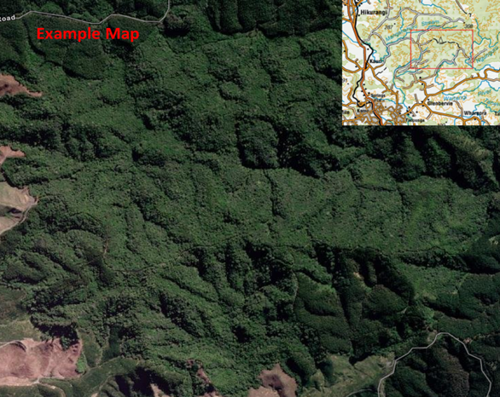

**Figure 1.** Location map

Proposed Operation

|  |  |
| --- | --- |
| **Provide a brief description of the proposed earthworks operation.** |  |
| **Land occupier (where applicable)** |  |

# Operators Information

|  |  |  |  |  |  |  |  |
| --- | --- | --- | --- | --- | --- | --- | --- |
| **Business/Company name:** |  | | | | | | |
| **Supervisor/Manager and Contact Details:** | |  | | | | | |
| **Name of person responsible for preparing this plan?** | | |  | | | | |
| **Subcontractor name(s):** |  | | | | | | |
| **Expected duration of earthworks:** | Start date: | | | | | End date: | |
| **How many personnel have completed a form of Kauri protection training?** | | | | | | |  |
| **Is work being carried out for a TLA, NZTA, utility or government agency as a contractor?** | | | | | | |  |
| **If so, which agencies?** |  | | | | | | |
| **Is this plan intended for a one-off operation?** | | |  | | | | |
| **Is this plan intended to include periodical maintenance?** | | | |  | Frequency: | | |
| ***Managers/supervisors are to ensure all personnel working on site understand the requirements in this plan*** | | | | | | | |

# Site and Kauri Information

|  |  |  |  |
| --- | --- | --- | --- |
| **Site location or property address:** |  | | |
| **Landowner/land manager/land occupier:** |  | | |
| **Contact details (phone and email):** |  | | |
| **Land Tenure:** |  | | |
| **Site or land description:** |  | | |
| **Is Kauri mapping information available?** |  | | |
| **Are the locations of all the Kauri within the site known?** | |  | |
| **Do any of the Kauri look sick or symptomatic for the disease caused by PA?** | | |  |
| **Will the operation impact the surrounding land** (points to consider, contiguous forest, location of Kauri, topography, cultural and historical areas, different land tenures or uses)? |  | | |

# PA Management

This section of the plan describes how the risk of PA spread is identified and managed via the following:

* Risk Matrix identifies the level of risk posed by an activity or a vector (pathway for movement of PA)
* PA mitigations and actions table details how PA is managed for each vector
* The success of PA management comes in the implementation of mitigations or actions.

Risk Matrix

Vectors or activities have been placed in the matrix according to the risk they pose based on relevant factors.(See **How to Guide** – Risk Matrix for full explanation). Some potential vectors are pre-filled, additional vectors may be added.

|  |  |  |  |  |
| --- | --- | --- | --- | --- |
| **Likelihood** | **Consequence** | | | |
| **Minor (A)** | **Moderate (B)** | **Significant (C)** | **Severe (D)** |
| **Highly Likely (4)** |  |  | **Stockpiling materials (overburden, sand, gravel)**  **Quarrying** | **Earthmoving machinery**  **Forestry operations** |
| **Likely (3)** |  | **Off track (into forest on foot)\*** | **Motorised equipment** | **Truck transport**  **Farm machinery**  **Water management** |
| **Possible (2)** | **Foot traffic on track** |  | **Tools and equipment**  **Any vehicle on gravel roads** | **Landscaping**  **Revegetation** |
| **Unlikely (1)** |  |  |  |  |

*Off track includes: soil sampling, research plot monitoring, trapping, treatments

## PA Mitigations and Actions

The table below identifies vector, risk rating, mitigations and actions for this earthwork’s activity (See **How to Guide** and **Appendix 1** for detail on procedures and actions). Add rows as needed.

|  |  |  |
| --- | --- | --- |
| **Risk and Description** | **Risk Rating Before** | **Actions to achieve plan objectives (mitigations)** |
| **Earthmoving machinery**  *List machinery types, group similar machinery together if the mitigations are the same* | **Very** High | *Dot point description on action taken to reduce the risk. See* ***How to Guide*** *for assistance.* |
| **Transport**  Driving on unsealed, un-gravelled roads | **High** |  |
| Driving on gravel roads | **Medium** |  |
| Semi-Trailer use | **Very**  **High** |  |
| Machinery in transport | **Very**  **High** |  |
| Dirt / sludge in transport | Very High |  |
| Vehicle Hygiene station use | **Very**  **High** |  |
| **Stockpiling**  Overburden, soil, gravel, landscaping material | **Very High** |  |
| Importing soil or vegetative matter | **Very High** |  |
| **Water management** | **Very High** |  |
| **Tools, Equipment** | **Medium** |  |
| **Footwear**  Off track use | **Medium** |  |
| **Staff**  Understanding of PA risk management | **Very High** |  |
| **Seasonal Activities**  Winter operations | Very High |  |
| Summer operations | **M** |

## Management Map

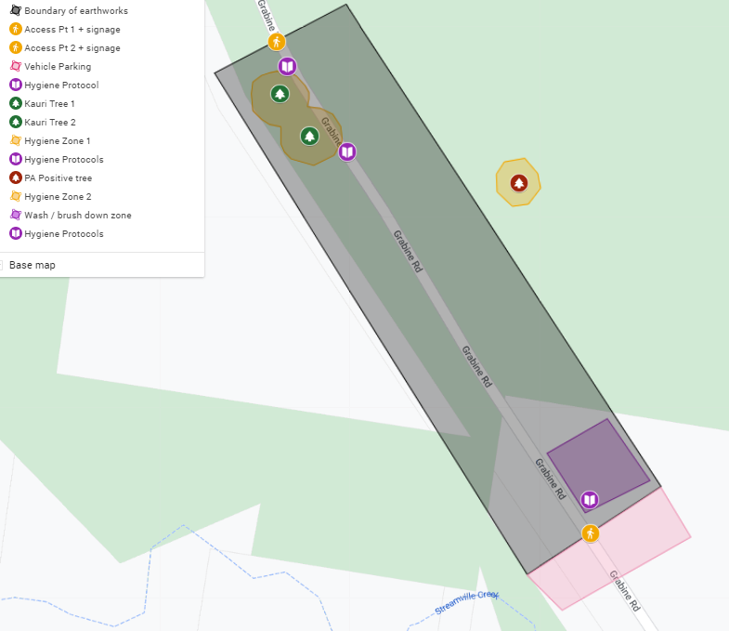Insert a Management Map. See **How to Guide** on detail required for a management map to satisfy this section of the rule. Below is an example of a management map required for an earthworks PA risk management plan.

**Figure 2.** Earthworks Risk Management Map containing all the required information

Conclusion

Provide a conclusion to the plan. **See How to Guide** for assistance.

# Reporting and Compliance

A completed Earthworks Risk Management Plan must be approved by an Authorised Person under the National PA Pest Management Plan prior to work commencing.

**How to submit and report**

Please email [KauriAuthorisedPerson@mpi.govt.nz](mailto:KauriAuthorisedPerson@mpi.govt.nz) , along with the individual Authorised Person that advised one was required (if applicable), to:

* Submit the completed Earthworks PA Risk Management Plan
* Advise of alterations to the start and end date of the earthworks
* Report significant non-compliance with an approved plan (immediately)
* Report on general compliance with an approved plan at the end of works or annually (by the anniversary of approval)

|  |  |  |  |  |  |  |  |  |
| --- | --- | --- | --- | --- | --- | --- | --- | --- |
| **Reporting and Compliance** | | | | | | | | |
| **Operator to fill out** | | | | | | | | |
| Will all personnel working on site read and follow this plan? | | | | | | | |  |
| Has the lands occupier received a copy of this plan? | | | | | | | |  |
| Is soil being transported to landfill: Yes/No | | | | | | | |  |
| If yes, which landfill facility? | | | | | | | | |
| Name of contractor: | | | Contact number: | | | | | |
| Agency: | | | Email: | | | | | |
| Manager/supervisor name and initial: | | | | | | | | |
| **Inspector or authorised person to fill out** | | | | | | | | |
| Assessor: | | | | | | | | |
| Does the plan comply with Rule 5 of the PA NPMP? Yes/No Initial: | | | | | | | |  |
| If not, why not | | | | | | | | |
| Has non-compliance been reported? | | | | | | | |  |
| Date assessed: | | | | Frequency of re-assessment (if required) | | | | |
| Date of next assessment: | | | | Officer Sign: | | | | |
| **Reassessments** | | | | | | | | |
| Date of reassessment: | | Outcome: | | | | Assessor: | | |
|  | |  | | | |  | | |
| **Compliance reporting** | | | | | | | | |
| Date | Incidence | | | | Outcome | | Assessor: | |
|  |  | | | |  | |  | |
|  |  | | | |  | |  | |

## **Procedures for PA Management**

Section (4) (d) to (h) refers to **procedures** required to prevent PA spread through earthworks activities. The following high-level procedures are to be followed in relation to these earthworks to satisfy rule 5 of the PA NPMP. The detail for each is represented as **actions** in the mitigations table in the “PA Management” section.

**Hygiene (4)(d)**

* Hygiene for preventing PA spread is achieved by removing all dirt from all surfaces. The procedure includes checking to ensure dirt free status followed by sterilising using an appropriate disinfectant. This applies to all vectors from footwear to tools to vehicles and machinery.

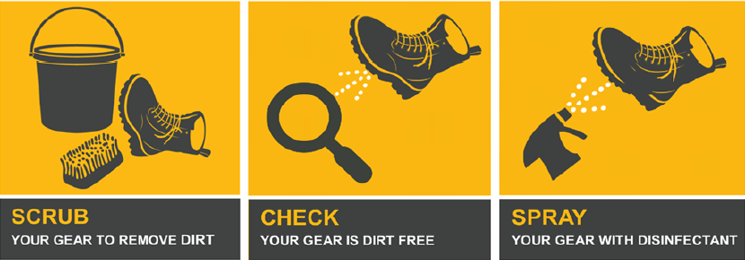

**Figure 3.** Hygiene instructions stepped process

* Hygiene may be achieved by using a solution wash or high pressure clean with a water-soluble disinfectant. However, this solution wash for small items (boots and tools) or run off from larger items (vehicle) needs to be disposed of appropriately in an approved location, which may be either on or off-site.

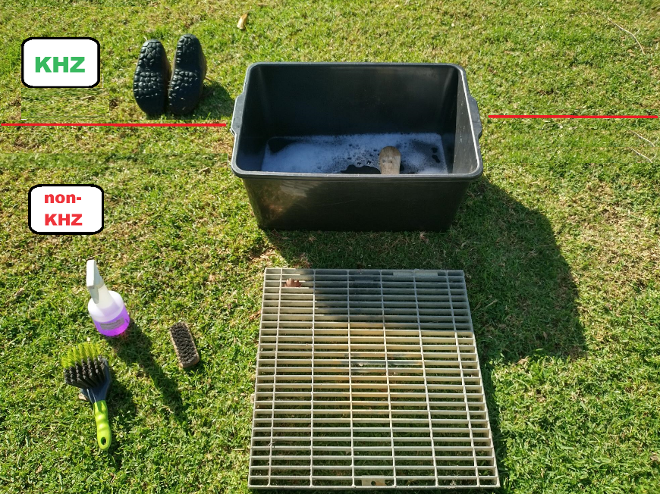

**Figures 4.** A container used for solution wash with grates to stop wet footwear from touching the ground and prevent recontamination (see **How to Guide** for more info)

* Hygiene must be carried out prior to entering and exiting a KHZ.

*The Kauri Hygiene Zone (KHZ) is the immediate vicinity of a tree which encompasses the trunk and the root system of a tree or stand of trees with overlapping root systems. No dirt movement is to occur in or out of this area. The perimeter of the KPA is 3 x the drip line of the individual tree or the most outlying tree in the stand*

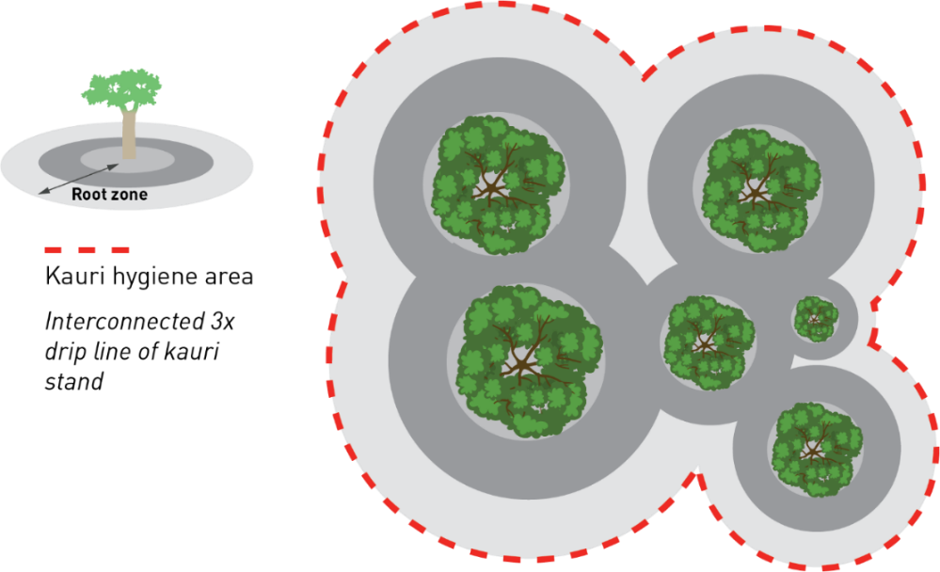

**Figure 6.** Aerial view of the **Kauri Hygiene Zone (KHZ)** where hygiene is required in and out of the zone

**Water Management (4)(f)**

* Water must be managed in a manner to prevent the potential movement of PA into KHZ’s, Kauri forest or water courses via appropriate drainage or containment.

**Soil, Sludge and Runoff (4)(e)**

* On site hygiene involving wash downs of larger vectors like vehicles and machinery must contain suitable facilities for containing run off.
* Run off must be disposed of appropriately. Municipal waste streams are treated, so are among the best choices for waste discharge.
* Small amounts of soil, sludge or organic material may be left in situ within a KHZ provided the volume of material will not impact the surrounding environment. If the volume is larger or the risk is higher the material must be contained and transported to a suitable landfill.
* All soil being transported to landfill must go to an approved facility.

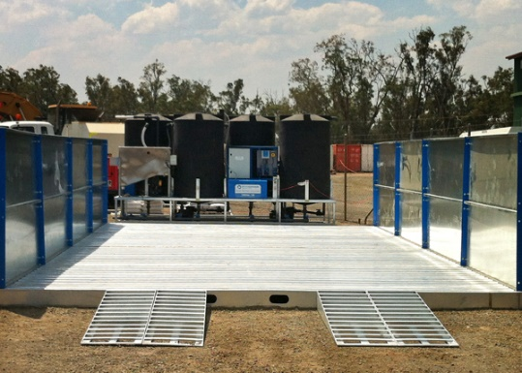

**Figure 7**. An example of an onsite vehicle or machinery hygiene station that has the capacity to contain and store runoff, soil and sludge

**Plan Awareness** **(4)(g)**

* All personnel entering earthworks site must be familiar with this plan and understand what is required of them in terms of mitigating PA risks.

References

Provide a reference and or links to the plan. See **How to Guide** for assistance.