Earthworks Risk Management

Plan

**How to Guide** for developing an earthworks risk management plan

# Background Information

This section provides important background information on Kauri, the pathogen and disease. **Do not delete or alter the content of this section.** Reading and retaining this section ensures a better understanding on why earthworks risk management plans are required.

# PA National Pest Management Plan (PA NPMP)

This How to Guide has been developed to assist in the preparation of an Earthworks PA Risk Management plan and to be authorised under the **PA NPMP Rule 5**.

**Underlined sections are legally required to satisfy rule 5. All other sections form part of best practice for manging PA and although not legally required should be included as part of understanding and implementing Kauri protection measures**

**Rule 5**

The **PA NPMP** **Rule 5** earthworks PA risk management plan; applies to **an occupier of land that includes a Kauri Hygiene Zone (KHZ)**. The occupier must not undertake earthworks in a Kauri hygiene zone unless they have, and operate in accordance with, an earthworks risk management plan that is approved for that land by the management agency, an inspector, or an authorised person.

A person permitted by an occupier to undertake earthworks on land in a Kauri hygiene zone (KHZ) must not undertake the earthworks unless the occupier has provided the person with an earthworks risk management plan **approved** for that land; and the person operates in accordance with that plan. The full description of the PA NPMP Rule 5 can be found [here](https://www.legislation.govt.nz/regulation/public/2022/0208/latest/LMS711681.html).

**Submitting for approval**

If an authorised person has requested you prepare this plan, please return the completed template to this individual and include the following email in the cc line: [KauriAuthorisedPerson@mpi.govt.nz](mailto:KauriAuthorisedPerson@mpi.govt.nz)

All other plans can be sent directly to: [KauriAuthorisedPerson@mpi.govt.nz](mailto:KauriAuthorisedPerson@mpi.govt.nz)

# Objective

Section (3) of plan rule 5 states, the objective of a earthworks risk management plan is “to manage and mitigate the risk of the spread of PA by earthworks and earthmoving operations”.

This objective applies to an occupier of land that includes a KHZ. An earthworks risk plan must meet the objectives of rule 5 and should be clearly stated in this section of the plan.

# Location Map

Insert a topographic or aerial image map of the location of the earthwork’s activity. Where possible include a higher-level map to identify the general area as well as a lower-level map identifying the earthworks area. Free maps and aerials can be viewed and printed at Arc GIS online or via using Google maps on following link <https://support.google.com/mymaps/answer/3024454>

# Proposed Operation

Provide a brief description of the proposed earthworks operation in the table provided. Also state the land occupier as the rule requires the land occupier to develop the plan.

# Operators Information

Complete the table by providing the necessary detail relating to the earthwork’s operator. Note some sections of this table are legally required.

# Site and Kauri Information

By completing this section, you are providing important information about the site and the location of kauri which greatly assists in managing the pathogen PA by knowing the existence of KHZ’s in relation to the earthworks. Complete the table as best you can for the site.

# PA Management

The detail in Rule 5 requires procedures to be in place to mitigate the potential spread of PA via earthworks activities. The process of mitigating PA spread involves best practice risk identification followed by understanding procedures and determining the appropriate action to prevent PA spread. This section details the risk, procedures and actions.

Risk management is an important best practice tool for managing PA risk. It’s not legally required in and Earthworks Risk Management Plan but is strongly recommended as part of understanding the process of PA management.

#### Risk Matrix

The risk matrix indicates the **likelihood** and **consequence** of each vector (pathway for movement of PA) or activity spreading potentially infected material based on three factors. These are:

* the volume of soil or dirt that can potentially be moved by a vector
* wet muddy ground conditions that occur in winter, fringes of winter (September to November and May) and immediately after (days) rainfall events between December and April
* frequency of vector over a period of time.

**Vectors or activities have been placed in the matrix according to the risk they pose based on the above factors. These are not negotiable unless the operator can provide detail in the plan that:**

* the activity will be carried out in summer
* the activity will cease for 3 rainfall-less days after a rainfall event (depending on volume)
* the frequency will be well mitigated by avoidance of kauri and if not then by hygiene

**The PA Mitigations and Actions table must accurately reflect the risk each vector poses.**

The **Likelihood** rows represent the chances of dirt containing, or possibly containing, PA from being picked up and moved around. Whether PA is present or not is often unknown so it needs to be managed as if it is present. Unlikely implies its possible but either in small amounts or low frequencies. Highly likely implies that, if PA was to be present in the area, itis almost certainly going to be moved.

The **Consequence** columns represent the significance of the impact of the introduction of PA either because of the location (directly in or above a KHZ) or the volume of material which in turn implies increase in the possibility of PA being present or volume of PA present.

**Tip:** The plan writer must replace each **vector** in the matrix with the specific item being used for the activity. For example: replace ‘machinery’ with ‘12 tonne digger’ if that is a machine that’s being used. If there is uncertainty as to the risk level of a particular **vector** place it in the matrix as you see fit. An authorised person will review and provide feedback as required.

|  |  |
| --- | --- |
| **Risk Matrix Legend** | |
| **Low** | An acceptable level of risk and no further action is required provided that the risk is kept to a minimum |
| **Moderate** | Further action required to minimise the risk. Review and implement suitable controls. |
| **High** | Immediate further action, possible stop work. Level of risk is unacceptable. Immediate review and implement suitable controls. |
| **Very high** | The level of risk is unacceptable and urgent attention is required to reduce the risk. Immediate stop work and revise controls |

Procedures for PA Management

Section (4) (d) to (h) refers to **procedures** required to prevent PA spread through earthworks activities. The following high-level procedures are to be followed in relation to these earthworks to satisfy rule 5 of the PA NPMP. The detail for each is represented as **actions** in the mitigations table below.

**Hygiene (4)(d)**

* Hygiene for preventing PA spread is achieved by removing all dirt from all surfaces. The procedure includes checking to ensure dirt free status followed by sterilising using an appropriate disinfectant. This applies to all vectors from footwear to tools to vehicles and machinery.
* Hygiene may be achieved by using a solution wash or high pressure clean with a water-soluble disinfectant. However, this solution wash for small items (boots and tools) or run off from larger items (vehicle) needs to be disposed of appropriately in an approved location, which may be either on or off-site.
* Hygiene must be carried out prior to entering and exiting a KHZ.

**Water Management (4)(f)**

* Water must be managed in a manner to prevent the potential movement of PA into KHZ’s, Kauri forest or water courses via appropriate drainage or containment.

**Soil, Sludge and Runoff (4)(e)**

* On site hygiene involving wash downs of larger vectors like vehicles and machinery must contain suitable facilities for containing run off.
* Run off must be disposed of appropriately. Municipal waste streams are treated, so are among the best choices for waste discharge.
* Small amounts of soil, sludge or organic material may be left in situ within a KHZ provided the volume of material will not impact the surrounding environment. If the volume is larger or the risk is higher the material must be contained and transported to a suitable landfill.
* Is soil being transported to landfill: Y/N
* If yes, which landfill facility ____________________

**Plan Awareness** **(4)(g)**

* All personnel entering earthworks site must be familiar with this plan and understand what is required of them in terms of mitigating PA risks.

## PA Mitigations and Actions

The next step in this process after the risk level has been identified is to understand procedures required for achieving PA management outcomes. These are described as mitigations or actions. Detail on procedures can be found below as well as under Appendix 2 - Actions for meeting the plan objectives of the plan template.

The table below is to be filled out by the operator who is responsible for implementing the plan. Use the table below to assist in completing this section of the plan.

**Tip:** Group like vectors together if they have the same mitigations and actions. There is no need to list all the different machinery or equipment if they have the same management actions.

**Tip:** The table below is detailed with best practice actions. Copy and paste them into your plan for each vector relevant to the earthwork’s activity. Actions can be added or subtracted from the table provided they meet the legal criteria of the plan.

|  |  |  |
| --- | --- | --- |
| **Risk and Description** | **Risk Rating** | **Actions to achieve plan objectives (mitigations)** |
| **Machinery**  Earthmoving machinery – include but are not limited to diggers, loaders, scrapers, graders and tractors  *List machinery types, one per row* | **Very High** | * Clean yard or a depot. Remove all dirt and vegetative matter. High pressure clean, disinfect * Transport to site clean * Machinery unloaded clean into KHZ * Set up physical barrier on boundaries of zones * Machinery remains in the zone for the duration. Avoid crossing boundaries. Separate machinery for separate zones * Post operation, prior to loading onto a truck, remove loose dirt, vegetative matter without use of water or a wash down * Carry out appropriate hygiene at yard, depot or cleaning facility |
| **Transport**  Driving on unsealed, un gravelled roads | **High** | * Transport vehicles to remain outside the KHZ unless they have arrived clean to site and remained on sealed surfaces (including compacted gravel). * Ensure access and turnaround doesn’t impact KHZ Transport to depot or yard for thorough hygiene and washdown |
| Driving on gravel roads | **Medium** | * Clean at car clean place or a depot. Remove all dirt and vegetative matter. High pressure clean, disinfect. |
| Semi-Trailer | **Very High** | * Transport vehicles to remain outside the KHZ unless they have arrived clean to site and remained on sealed surfaces (including compacted gravel). * Ensure access and turnaround doesn’t impact KHZ Transport to depot or yard for thorough hygiene and washdown |
| Machinery in transport | **Very High** | * Transport vehicles to remain outside the KHZ unless they have arrived clean to site and remained on sealed surfaces (including compacted gravel) * Machinery to be loaded after dry brush down * Wash down on site not preferred unless containment can be done and recontamination avoided * Transport direct to depot or yard for thorough hygiene and washdown |
| Dirt / sludge in transport | **Very High** | * Contain the run off in a sump, tank or pond. Which option taken is determined by the need to remove off site or not which is dictated by volume. * Load onto appropriate transport * Transport to suitable landfill to unload |
| **Stockpiling**  Overburden, soil, gravel, landscaping material | **Very High** | * Material from a KHZ is to be contained on site in the first instance * Cover to prevent movement of dirt via water or wind. * Bund stockpile areas to prevent movement of dirt via water flow * Excess material can be left in situ depending on the volume and the operation. * Alternatively, material will need to be transported off site to an approved facility. This will need to be done in a manner not to ‘lose’ material whilst being transported |
| Importing soil or vegetative matter | **Very High** | * Infill in a KHZ must be sourced from within the KHZ itself. If this can not be achieved the infill must be obtained from a PA free source. |
| **Water Management** | **Very High** | * Prevent the risk of water potentially spreading PA into a KHZ or Kauri Forest or via connected watercourse. * Set up appropriate drainage and bunding on site to capture and hold run off or water flow. * Be prepared for the impact of rainfall events on site and the movement of run off |
| Driving on gravel roads | Medium | * Clean at car clean place or a depot. Remove all dirt and vegetative matter. High pressure clean, disinfect. |
| Vehicle Hygiene station use | **Very High** | * Set up station away from KHZ using minimum standard equipment. * Traffic flow can’t pass by the station uninhibited * Dry hygiene on entry and exit of KHZ * Contained dirt and run off to be transported off site. * Ensure hygiene platform is kept clean and dirt free before and after use |
| **Tools, Equipment** | **Medium** | * Arrive clean and leave clean (means clean at a yard or depot). * Clean between KHZ’s if moving between them is necessary * On site hygiene is easier to achieve and manage for tools, equipment and footwear. * Dedicated piece of equipment or boots are recommended per KHZ. |
| **Footwear**  Foot traffic off track | **Medium** | * Set up on boundaries of KHZ’s. * Must contain minimum standard for temporary footwear and tools hygiene station. * A change in footwear is recommended to minimise hygiene requirements. * Scrub and disinfect on entry and exit. |
| **Seasonal Awareness**  Winter activities, fringes of winter and rainfall events | **Very High** | * Avoid wet ground activities as much as possible. Avoid access into KHZ’s as much as possible. |
|
| Summer activities | **Medium** | * Dry soil access by carrying out activity or operation in the drier months of the year from late Spring to early Autumn, avoiding rainfall events. |
| **Staff**  Understanding of PA risk management | **Very High** | * Staff to be trained in Kauri protection and hygiene. * Different types of training may be required for managers compared to staff on ground managing contractors. * All staff to read and understand this earthworks risk management plan prior to commencement of earthworks operation. * A copy is to be made available on site. |

The last step of the PA mitigations and actions section is implementation. Ensure these actions above are implemented appropriately to meet rule criteria and kauri protection best practice.

Management Map

The purpose of the management map accompanying this plan is to display all aspects required under the Rule 5 definition. Section (4)(c) of plan rule 5 states the information to be provided in a map of the land. As a minimum requirement the following legal elements must be included:

* Kauri tree locations
* Boundary of any earthworks
* Access points across the earthworks site
* Signage locations, both for access and hygiene protocols
* Where vehicles may be parked
* Hygiene points, where items contaminated with soil will be washed/cleaned with signage

Free maps and aerials can be viewed and printed at Arc GIS online or via using Google maps on following link <https://support.google.com/mymaps/answer/3024454>

# Conclusion

This management plan covers all aspects of the intended activity or operation that have the potential to move dirt with appropriate mitigations applies to reduce the risk as much is reasonably practicable. The map provided indicates relevant management aspects and with this plan demonstrate how mitigating vectors will be achieved. Auditing of these process will be carried out randomly during the activity or operation. Expand as required.

# Reporting and Compliance

See the table in the plan**.** Answer all the questions. A representative from the management agency, an inspector or authorised person to complete their section.

# Reference Links

Identify and list the documents used to assist completing this plan. Include research, publications, Tiakina website and council websites. Insert links in plan.

**National programme website. Management agency is Tiakina Kauri.**

[Give Kauri Space to Grow | Tiakina Kauri (Kauriprotection.co.nz)](https://www.kauriprotection.co.nz/)

[Resources | Tiakina Kauri (Kauriprotection.co.nz)](https://www.kauriprotection.co.nz/resources/)

[National Plan | Tiakina Kauri (Kauriprotection.co.nz)](https://www.kauriprotection.co.nz/national-plan/)

[Principles of hygiene | Tiakina Kauri (Kauriprotection.co.nz)](https://www.kauriprotection.co.nz/resources/best-practice-guides/protecting-kauri-principles-of-hygiene/).

**New Zealand legislation website. New NPMP came into effect 2nd August 2022.**

[Biosecurity (National PA Pest Management Plan) Order 2022 (SL 2022/208) Contents – New Zealand Legislation](https://www.legislation.govt.nz/regulation/public/2022/0208/latest/LMS711621.html?src=qsrather)

# Appendices

Appendices in this plan provide additional information which assist in implementing this plan. Include the appendices below as required.

Hierarchy of Prevention

|  |  |  |
| --- | --- | --- |
| **Preference** | **Prevention Measure** | **Description** |
| **Most Preferred** | Avoid | Completely avoid Kauri forests, stands, hygiene areas, KHZ’s where possible. Substitute the location of the operation or time of year to protect Kauri by avoidance through substitution. |
| Avoid Infected Sites | If avoiding all Kauri hygiene areas isn’t possible avoiding known infected sites as a minimum. Sampling and assessment of forest may be required to satisfy this preference. |
| Avoid Winter Activities | Avoid operations or activities in and around Kauri during winter, late autumn, early spring and rainfall events during the dry months of the year. |
| Administrative | Administration measure involves the provision of training, understanding the basic information around pathogen, disease, mitigations and hygiene. Apply this measure in the first instance. |
| **Acceptable** | Planning | Consider Kauri whilst planning activity or operation. Source background information on Kauri, pathogen and disease location. |
| Hygiene | Follow standard hygiene practice in removing dirt from all surfaces that come in contact with the ground. Once dirt is removed apply suitable disinfectant. |
| **Least Preferred** | Hygiene only | Follow the standard of hygiene only without first planning and considering Kauri as part of the activity or op. Reliance on practicing excellent hygiene all the times. |

How to identify Kauri

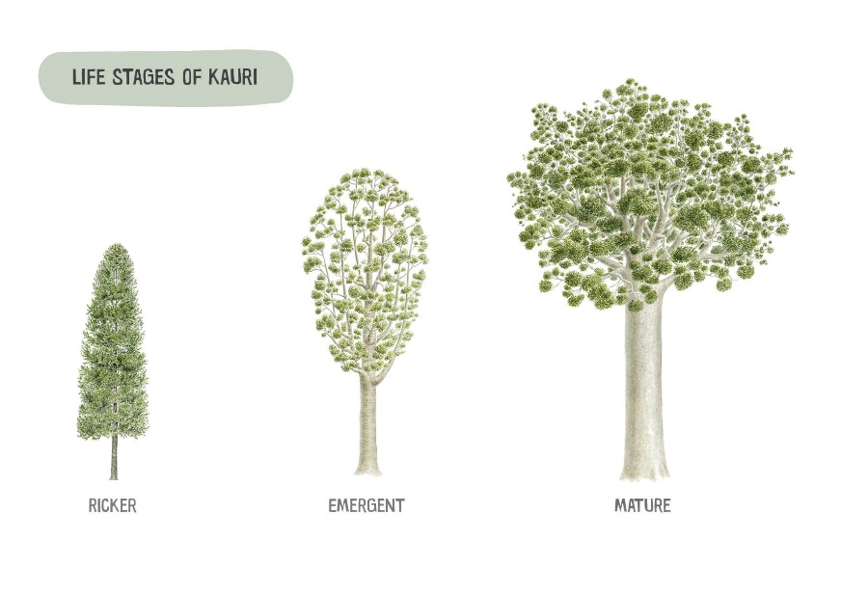

|  |  |
| --- | --- |
|  |  |
| Bark of a Kauri | Female seed cone/green foliage |
|  |  |
| Male seed pod | Varying colours of foliage in saplings |

Hygiene Information

Practicing appropriate hygiene is not the only way to prevent movement of dirt. Other methods include avoiding Kauri, having spare footwear for driving, a pair of boots for each location, dedicated tools or machinery, hanging a back pack in a tree, choosing boots with open tread that are easy to clean and using overshoe booties. Reducing the frequency of hygiene through smart planning is recommended. See Principals of Hygiene guide.

[Principles of hygiene | Tiakina Kauri (Kauriprotection.co.nz)](https://www.kauriprotection.co.nz/resources/best-practice-guides/protecting-kauri-principles-of-hygiene/)

|  |  |  |
| --- | --- | --- |
| **Hygiene equipment** | | |
|  | |  |
| **Minimum requirement in backpack**:   * 1-2x stiff bristle brush * 500ml spray bottle with disinfectant * 1x 1L Solo pump sprayer with water * Boot bag * Overshoe booties   Consider having a designated pair of boots for working in the KHZ. Clean them once then leave them in a container on site in the KHZ so you can put them on before stepping into the KHZ | | **Minimum requirement for portable or temporary station with solution wash in a container:**   * 1-2x stiff bristle brush * 500ml spray bottle with disinfectant * 1x 1L Solo pump sprayer with water * Bin or tub to scrub with 2% sterigene solution wash * Grate to stand on to prevent recontamination before and after wash |
| It is recommended to have extra gear in a vehicle. This includes water and disinfectant supply, extra brushes and a container. The container maybe used to contain dirty gear that is to be taken back to a depot for thorough cleaning. Disinfectant can either 70-80% methylated spirits 20-30% water mix or 2% Sterigene. Meths dries quicker. **Note:** Check the denatured alcohol content from the manufacturer. Some meths are diluted somewhat during manufacture and may not need further dilution as a disinfectant. | | |
| Key messages:  **Arrive Clean. Leave Clean**  **Scrub, Check and Spray** |  | |

Kauri Hygiene Zone (KHZ)

The Kauri Hygiene Zone (KHZ) is the immediate vicinity of a tree which encompasses the trunk and the root system of a tree or stand of trees with overlapping root systems. No dirt movement is to occur in or out of this area. The perimeter of the KPA is 3 x the drip line of the individual tree or the most outlying tree in the stand. See graphics below.

**Image 1. Aerial view of the KHZ’s of a stand of Kauri**

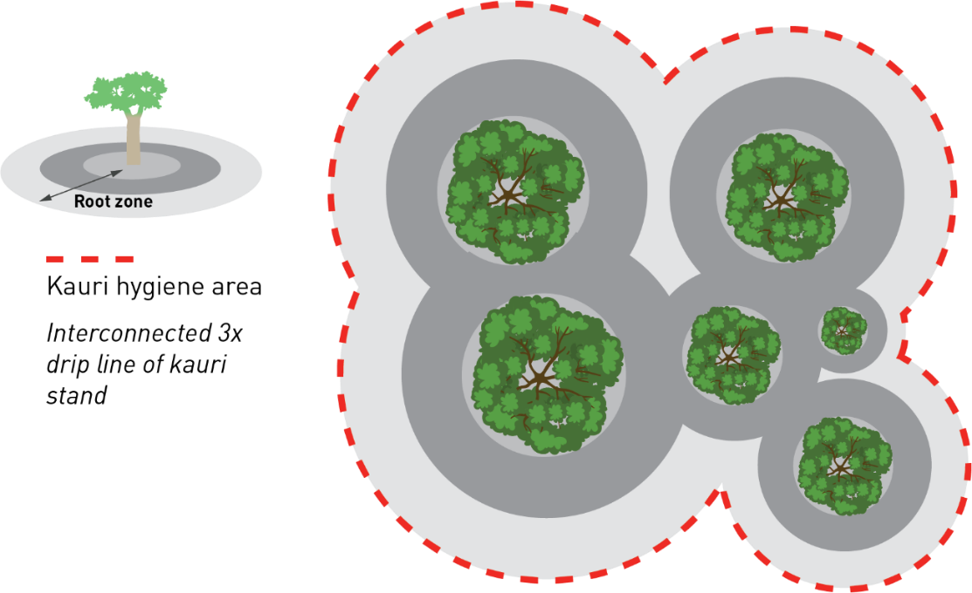

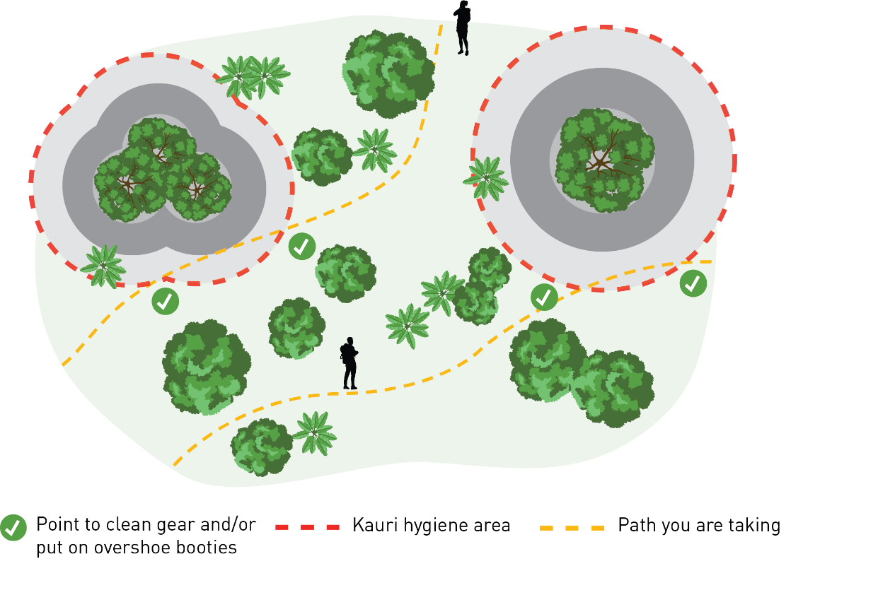

**Image 2. Aerial view of the KHZ’s, walk tracks and where to carry out hygiene**

Vehicle and Machinery Hygiene

Vehicle and machinery hygiene must be carried out using suitable equipment preferably at a depot or yard. For a temporary on-site station equipment must include a grated platform, sides to contain splash, water and waste tanks, high pressure cleaning equipment and a catchment are to be able to contain, treat and or dispose of run off. The process involves dry removal, then wet removal of dirt via high pressure. Check all surfaces are dirt free and then spray disinfectant on tyres and tracks. The following are examples of the type of equipment/set up required for a temporary on-site station.

|  |  |  |
| --- | --- | --- |
|  | |  |
| **How does a vehicle and machinery hygiene station work?** |  | |
| **Where do I need to clean on vehicles?**  See checklist for vehicle and machinery hygiene |  | |

How to identify sick Kauri

The following are symptoms of PA related disease in Kauri.

|  |  |  |  |
| --- | --- | --- | --- |
|  |  |  |  |
| BASE BLEEDING –  This occurs specifically from the base of the tree as the disease progresses up from the root system. | CANOPY DECLINE –  Gradual decrease of branches spreading to the entire canopy. Decline varies from minor to severe. | FOLIAGE COLOUR –  Severe change in colour of foliage from green to yellow to red-brown as the disease progresses. | TREE DEATH –  The tree has succumbed to the disease to its full extent. |

Glossary of Terms

|  |  |
| --- | --- |
| **Kauri disease** | Disease having a high death rate in Kauri as of a result of infection by a root rot pathogen. |
| **Pathogen** | A bacterium, virus, oomycete or other microorganism that can cause disease. |
| ***Phytophthora agathidicida (PA)*** | The microscopic, soil-borne pathogen which specifically causes disease in NZ Kauri. |
| **Positive** | A test result that confirms the presence of *P. agathidicida* in a soil and root sample . |
| **Undetected** | A test result that does not confirm the presence of *P. agathidicida* in a soil and root sample. Note, a negative test result is not always a true reflection of the pathogen or disease status of the tree or surrounding environment, as *P. agathidicida* may not have been picked up in that particular soil and root samples or the test may not have been sensitive enough to detect it from the sample. |
| **Introduction pathway** | A place where a vector is/was most likely to have brought the pathogen to a new place, such as a track, trapline, track entrance, historic disturbance site, etc. |
| **High risk site** | A site that contains a confirmed positive tree or is near a positive tree, contains numerous vectors and/or introduction pathways. |
| **Low risk site** | Contains undetected sample results with low number of vectors and/or introduction pathways and is not adjacent to a positive result. |
| **Mitigation** | The action of reducing the impacts of Kauri dieback disease through the implementation of appropriate hygiene management techniques. |
| **Hygiene management** | Recommendations made around the best practice for preventing the spread of soil, infected or otherwise. |
| **PA Management** | Prevention of the movement of dirt and pathogen using the risk-based approach and mitigations |
| **Hygiene** | Practice of maintaining dirt or soil free footwear, equipment, vehicles and machinery through cleanliness. |
| **Hygiene point** | The location on the edge of a forest or Kauri Protection Zone whereby hygiene practices are to be carried out. A hygiene point maybe where a station is established or where hygiene occurs with a personal kit. |
| **Kauri Hygiene Zone (KHA/Z)** | The root zone area of a Kauri that requires protection and hygiene measures. This area encompasses 3x the drip line of the tree. |
| **Drip line** | An approximate line on the ground directly below the outer most branches of the canopy where rain falls from the foliage to the ground. |
| **Vector** | a method of transferring infected soil from one area to another. Vehicles, footwear and dirt roads are examples of vectors. |